A DECADE OF INNOVATION AND SUCCESS

Dr. Ulf Reinhardt honored for ten years at LAUDA

Lauda-Königshofen, 22 February, 2024 – LAUDA is pleased to congratulate Dr. Ulf Reinhardt on his ten-year work anniversary. As Managing Director of the subsidiary LAUDA Scientific, which was only founded in 2015, Dr. Reinhardt has made a significant contribution to the development of the measuring devices since joining the company on January 1, 2014 and has had a lasting impact on their visibility on the market.

Dr. Gunther Wobser, President & CEO of LAUDA DR. R. WOBSER GMBH & CO. KG, recalled their first meeting during a factory tour in the region in May 2011 and their first clash in a tennis match in the middle of July 2011 in his entertaining address. “A decade of service at management level is a special occasion, on which I offer my personal congratulations. Together with your dedicated team, you have established LAUDA Scientific on the market and given the company a face, personality and visibility“, said Dr. Wobser. He highlighted the numerous milestones that Dr. Reinhardt has achieved - from a new brand image with its own corporate design to an independent trade fair stand and further development in the areas of production and marketing. “You combine the best of both worlds, as you embody key functions covering all aspects of scientific methodology, development and sales and link them seamlessly with the structures of LAUDA as the parent company”, Dr. Wobser continued.

Dr. Reinhardt not only contributes the expertise gained from his chemistry studies and doctorate at Hamburg University but also his many years of experience as a sales manager, team leader for research & development and former managing director of a manufacturer for laboratory analytics and laboratory measurement instrumentation. This combination of scientific background and entrepreneurial vision characterizes LAUDA Scientific, where Dr. Reinhardt plays an important role as an absolute professional and visionary leader.

In his speech of thanks, Dr. Reinhardt looked back on the beginning of his time at LAUDA in 2014, when he not only registered the new company but concentrated on raising the profile of both the brand and the products of LAUDA Scientific with an inquisitive mind and great perseverance. “With an agile approach – from fresh marketing ideas to the introduction of product webinars – and a dynamic mindset in the team, we have been able to achieve a great deal in recent years and raise our profile. The current market situation remains challenging, but we are optimistic about the future thanks to the high level of incoming orders“, said Dr. Reinhardt. He thanked his entire team for their efforts and said that he was eagerly looking forward to the next ten years.

He was congratulated by the LAUDA management team and all the employees of LAUDA Scientific during a special ceremony. The President and CEO, Dr. Gunther Wobser, presented Dr. Ulf Reinhardt with the LAUDA certificate of honor as well as a certificate of honor of behalf of the Heilbronn-Franken Chamber of Industry and Commerce in recognition of his ten-year work anniversary at LAUDA Scientific and his commitment to the regional economy.

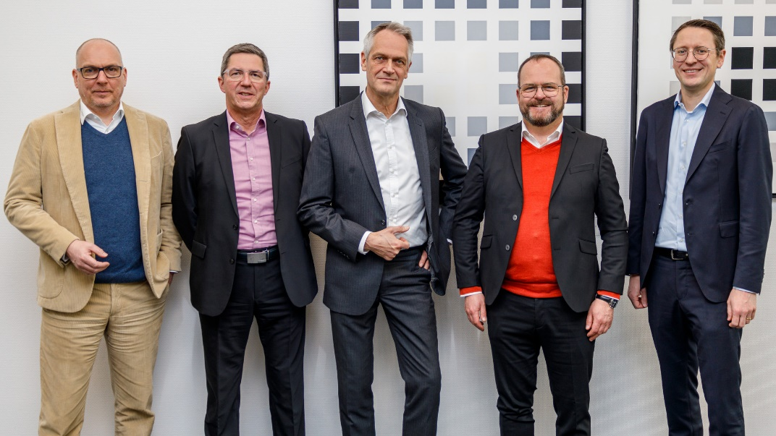
Image: Cause for celebration at LAUDA: Dr. Ulf Reinhardt, Managing Director of LAUDA Scientific, celebrated his ten years of service with the company.
In the company of colleagues and friends, he was congratulated by the management team of LAUDA DR. R. WOBSER GMBH & CO. KG (from left to right): Managing Directors Dr. Marc Stricker and Dr. Ralf Hermann, Dr. Ulf Reinhardt, the President and CEO, Dr. Gunther Wobser, and Managing Director Dr. Mario Englert. © LAUDA

We are LAUDA – the world leader in precise temperature control. Our constant temperature equipment and systems are at the heart of important applications, contributing to a better future. As a complete one-stop supplier, we guarantee the optimum temperature in research, production and quality control. We are the reliable partner for electromobility, hydrogen, chemicals, pharmaceuticals/biotech, semiconductors and medical technology. We have been inspiring our customers for almost 70 years with our expert mentoring and innovative solutions – every day anew and all over the world.

In our company, we always go one step further. We support our employees’ development and are constantly developing ourselves: to create a better future together.

Press contact
We are more than happy to make prepared information about our company, the LAUDA Factory Gallery and our projects in the area of innovation promotion, digitalization and idea management available to the press. We look forward to hearing from you – just give us a call!

CHRISTOPH MUHR
Head of Corporate Communications
T + 49 (0) 9343 503-349
christoph.muhr@lauda.de

LAUDA DR. R. WOBSER GMBH & CO. KG, Laudaplatz 1, 97922 Lauda-Königshofen, Deutschland/Germany. Limited partnership: Headquarters Lauda-Königshofen, Registration court Mannheim HRA 560069. General partner: LAUDA DR. R. WOBSER Verwaltungs-GmbH, Headquarters Lauda-Königshofen, Registration court Mannheim HRB 560226. Managing Directors: Dr. Gunther Wobser (President & CEO), Dr. Mario Englert (CFO), Dr. Ralf Hermann (CSO), Dr. Marc Stricker (COO)

