INNOVATIVE TEMPERATURE CONTROL TECHNOLOGY IN THE FOCUS OF THE PROCESS INDUSTRY
LAUDA presents innovations in temperature control at ACHEMA

Lauda-Königshofen, August 15, 2022 - ACHEMA, the world's leading trade fair for the international process industry, will gather experts, users and the trade press from all over the world in the Frankfurt exhibition halls from August 22 to 26, 2022. The LAUDA DR. R. WOBSER GMBH & CO. KG will present digital innovations from temperature control technology at its stand in Hall 4.0, Stand C26, and provide an insight into the possibilities in hydrogen cooling - one of the trend topics at this year's ACHEMA. In contrast to its previous trade fair appearances at ACHEMA, LAUDA is deliberately concentrating this year on the focal points of process engineering and process industry in order to bring its own experience and portfolio in the field of industrial temperature control to the fore.

»The process industry with its diverse applications and future-oriented developments is one of our most important target markets,« explains LAUDA CSO Dr. Ralf Hermann. »Thanks to our decades of work in this field, we have a profound understanding and the necessary expertise for the most demanding temperature control tasks in process technology. Accordingly, we are delighted to finally be able to present our latest developments to our customers and partners again in a presentable setting and provide new impetus.«

Process thermostats with native app control and digital products from LAUDA

In the field of reactor temperature control, LAUDA presents the new generation of LAUDA Integral process thermostats, powerful temperature control units with intuitive control via mobile devices. LAUDA is bundling its digital innovations under the trade fair motto EMPOWERING EXCELLENCE. FOR A BETTER FUTURE. With cleverly thought-out further developments in temperature control technology that optimally complement user processes and make them possible in the first place, LAUDA supports its customers in industries such as chemicals, pharmaceuticals, electromobility and hydrogen in improving the world with precise temperature control.

The smart networking of process technology and temperature control technology continues to advance with LAUDA.LIVE. With this digital platform, LAUDA temperature control solutions become fully networked and intelligent IoT devices. The digital products provide users with comprehensive asset management capabilities and smart analytics and monitoring tools, optimizing LAUDA equipment uptime, reliability and performance. A demonstration of LAUDA.LIVE awaits visitors at the LAUDA booth at ACHEMA.

LAUDA is demonstrating its extensive know-how in the process industry at ACHEMA with a LAUDA ITH heat transfer system for process temperature control. The industrial system offers working temperatures up to a maximum of 550 °C and a heating capacity of 3 - 500 kW, making it ideally equipped to handle individual temperature tasks in process industry applications. LAUDA experts on site will be happy to answer visitors' questions and discuss customized temperature control solutions.

If you would like a personal interview, our CEO, Dr. Gunther Wobser will be available from 24-26.8.22 and our Director of Product Management, Enrico Bossart will be available from 22-24.8.22 at the trade fair. Please contact us regarding this as early as possible so that we have sufficient time to plan and spend time with you and your questions. Thank you very much.

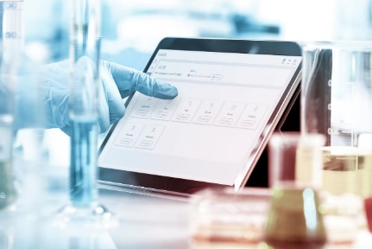  With LAUDA.LIVE, all temperature control and laboratory solutions become fully networked and intelligent IIoT devices. © lauda.de | LAUDA Integral process thermostats can be operated intuitively via mobile devices using the new Command App for Android, iOS and Windows. © lauda.de
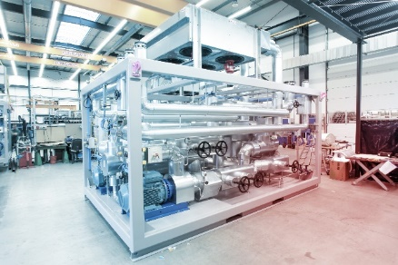
Perfect temperature control for the process industry: LAUDA shows industrial heat transfer systems at ACHEMA. © lauda.de

We are LAUDA – the world leader in precise temperature control. Our constant temperature equipment and systems are at the heart of important applications, contributing to a better future. As a complete one-stop supplier, we guarantee the optimum temperature in research, production and quality control. We are the reliable partner for electromobility, hydrogen, chemicals, pharmaceuticals/biotech, semiconductors and medical technology. We have been inspiring our customers for more than 65 years with our expert mentoring and innovative solutions – every day anew and all over the world.

Press contact
For the press, we are very happy to provide information about our company, the LAUDA FabrikGalerie and our projects in the field of innovation promotion, digitalization and idea management. We look forward to an open exchange with you - contact us!

ROBERT HORN CLAUDIA HAEVERNICK
Corporate Communications Manager Corporate Communications
T + 49 (0) 9343 503-162 T + 49 (0) 9343 503-349
robert.horn@lauda.de claudia.haevernick@lauda.de

