ANALYTICA 2022:
LAUDA DRAWS POSITIVE CONCLUSIONS
World market leader impresses with innovations and strategic realignment at Munich trade show

Lauda-Königshofen, June 24, 2022 - Nearly 26,000 visitors and 891 exhibitors from 39 countries came to Munich from June 21 to 24 for analytica 2022, the world's leading trade fair for laboratory technology, analysis and biotechnology. After the trade fair had to be cancelled in 2020 due to the Corona pandemic, the positive mood and the great urge for professional exchange could be felt throughout. After the four days of the 27th edition of the trade fair, LAUDA DR. R. WOBSER GMBH & CO. KG also draws a clearly positive balance. The world market leader for temperature control equipment and systems presented its product portfolio in six thematic application areas and demonstrated how LAUDA's innovative, digital solutions will bring the laboratory of the future into the present. Despite the uncertainty of the still ongoing pandemic, it was possible to build on the trade fair successes from 2018 - in terms of specific inquiries and customer contacts. The 25-strong trade fair team can thus look back on a very successful week. The motto of this year's trade show appearance of the world market leader "EMPOWERING EXCELLENCE. FOR A BETTER FUTURE" was omnipresent through the visual representation of a floating "Impact Cloud" above the entire booth and impressively illustrated the future technologies and application areas in which LAUDA is making its excellent contribution to improving the world bit by bit with exact temperatures.

"It was a great pleasure to be able to exchange ideas with our partners and customers directly and personally. It is precisely these technical discussions and direct contact that provide such important impetus from our industry," says Dr. Gunther Wobser, President and CEO of LAUDA and Deputy Chairman of the Advisory Board of the leading trade fair. "Particularly in 2022, after more than two years of pandemic, analytica was the perfect professional setting to present our innovations and the strategic reorientation of LAUDA to the trade audience. We are more than satisfied with the positive response and the large number of visitors to our stand, and we are very pleased with the many points of contact and the professional expertise that we were able to exchange during the most important leading international trade fair."

Process thermostats with voice control, mobile ultra-low freezers and digital products from LAUDA

The trade visitors were particularly interested in the product innovations on display, especially the world's first mobile ultra-low temperature freezer equipped with modern lithium-ion battery technology for the safe transport of vaccines, samples and pharmaceuticals. Temperature-sensitive active ingredients are stored and transported safely and in a controlled manner, CO₂ emissions are reduced and the occupational safety of logistics staff is significantly increased by dispensing with dry ice.

The new generation of LAUDA Integral process thermostats, which were developed for a comprehensive range of applications from -90 to 320 °C, an innovative temperature control unit with an intelligent interface concept and intuitive control via mobile devices, also impressed the visitors. With the pioneering technology demonstration "Hey LAUDA", the process thermostats can be operated by voice control for the first time. The devices can thus be controlled easily and conveniently via short and simple commands.

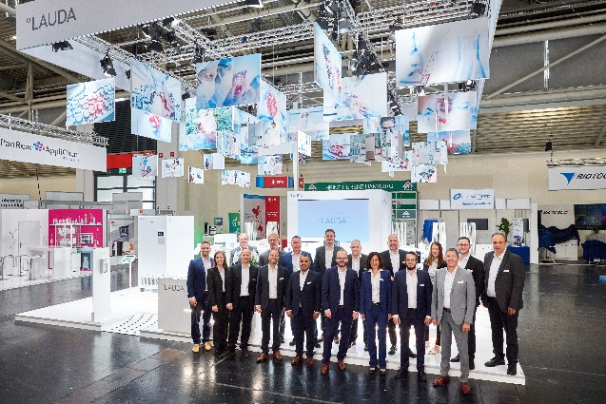  LAUDA booth with Team analytica 2022 © Behrend und Rausch | 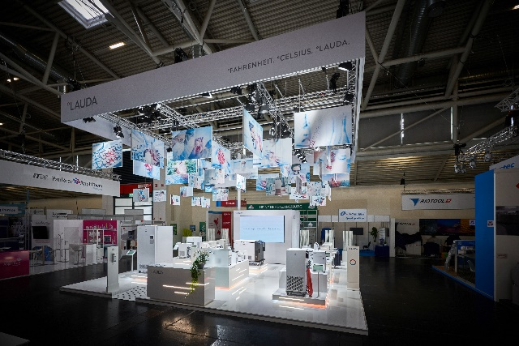  LAUDA booth at analytica 2022 © Behrend und Rausch
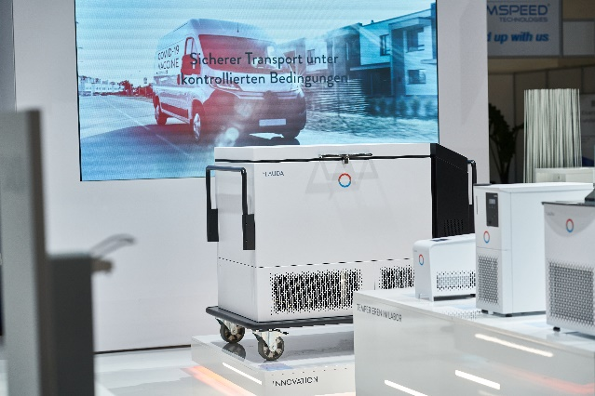  Mobile ultra freezers at analytica 2022 © Behrend und Rausch | 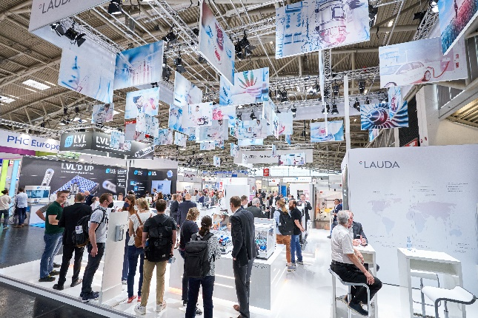  LAUDA booth with visitors, analytica 2022 © Behrend und Rausch

We are LAUDA – the world leader in precise temperature control. Our constant temperature equipment and systems are at the heart of important applications, contributing to a better future. As a complete one-stop supplier, we guarantee the optimum temperature in research, production and quality control. We are the reliable partner for electromobility, hydrogen, chemicals, pharmaceuticals/biotech, semiconductors and medical technology. We have been inspiring our customers for more than 65 years with our expert mentoring and innovative solutions – every day anew and all over the world.

Press contact
For the press, we are very happy to provide information about our company, the LAUDA FabrikGalerie and our projects in the field of innovation promotion, digitalization and idea management. We look forward to an open exchange with you - contact us!

ROBERT HORN CLAUDIA HAEVERNICK
Corporate Communications Manager Corporate Communications
T + 49 (0) 9343 503-162 T + 49 (0) 9343 503-349
robert.horn@lauda.de claudia.haevernick@lauda.de

